**Social Media Analytics Dashboard Report**

**1. Executive Summary**

The Social Media Analytics Dashboard is an innovative web application designed to provide real-time analytics for social media posts. Utilizing a robust technology stack including Flask, SQLite, and RabbitMQ, this system offers efficient post processing and immediate analytical insights. The project demonstrates the effective implementation of asynchronous processing in web applications, providing a scalable solution for social media content analysis.

**2. Introduction**

**2.1 Project Overview**

In the digital age, understanding the impact of social media content is crucial. This dashboard addresses this need by offering a platform where users can create posts and instantly receive analytical data. The project showcases the integration of various technologies to create a responsive, efficient, and user-friendly web application.

**2.2 Objectives**

1. Develop a user-friendly interface for effortless post creation and viewing
2. Implement real-time analytics processing for each post
3. Demonstrate effective use of a message queue for asynchronous operations
4. Create a scalable and maintainable codebase
5. Provide clear API endpoints for potential integration with other services

**2.3 Scope**

The current scope includes:

* User interface for post creation and viewing
* Backend system for post storage and retrieval
* Real-time calculation of basic analytics (word count and character count)
* Asynchronous processing using a message queue
* API endpoints for post creation and retrieval of posts with analytics

**2.4 Key Features**

* Post Creation: Users can create and submit new posts through a simple interface
* Real-time Analytics: Each post is automatically analyzed for word count and character count
* Asynchronous Processing: Utilizes RabbitMQ to handle post processing without blocking user interactions
* Recent Posts Display: Users can view recent posts along with their analytics
* RESTful API: Provides endpoints for programmatic interaction with the system

**3. System Architecture**

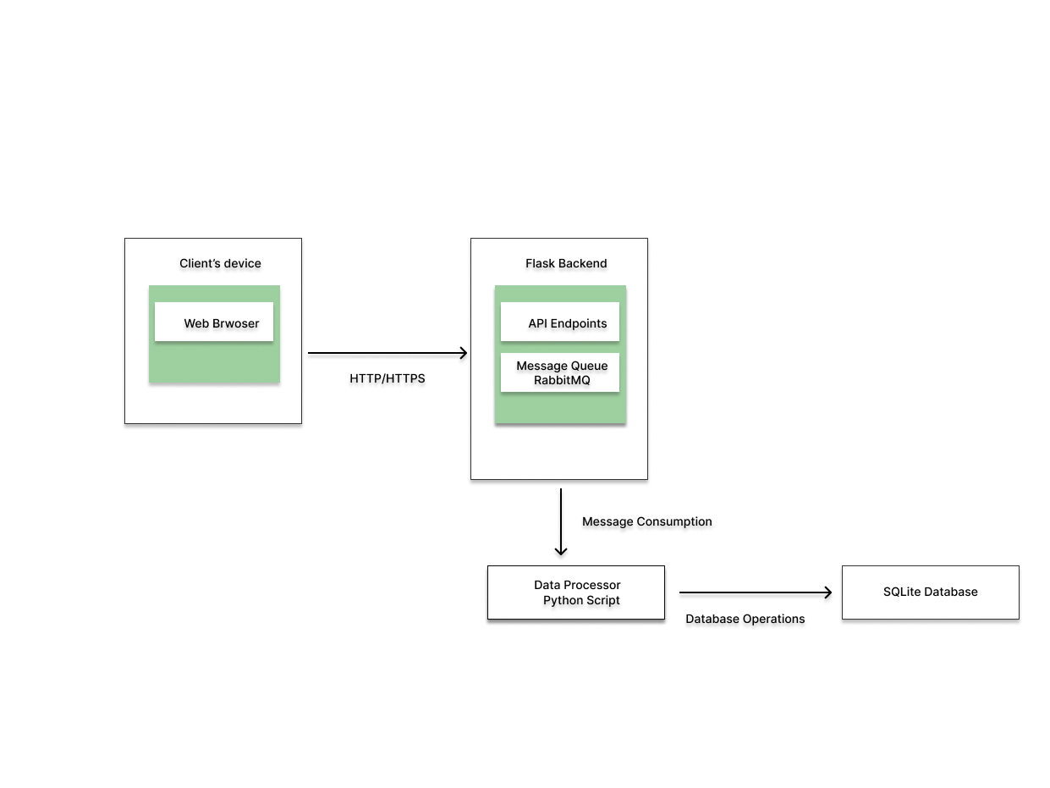

**3.1 High-Level Architecture Diagram**

1. Web Browser: The user interface where users interact with the application.
2. Flask Backend: Handles HTTP requests and hosts the API endpoints.
3. Message Queue (RabbitMQ): Manages asynchronous processing of posts.
4. Data Processor: A separate Python script that processes messages from the queue.
5. SQLite Database: Stores posts and analytics data.

The flow of data is as follows:

* Users interact with the web interface.
* The Flask backend receives requests and sends messages to RabbitMQ.
* The Data Processor consumes messages from RabbitMQ, processes them, and stores results in the database.
* The Flask backend can then retrieve processed data from the database to display to users.

**3.2 Component Overview**

1. Frontend:
   * Technologies: HTML, JavaScript
   * Purpose: Provides user interface for post creation and viewing
   * Key Features: Post submission form, display area for recent posts and analytics
2. Backend (Flask Application):
   * Technologies: Python, Flask
   * Purpose: Handles HTTP requests, manages API endpoints, interacts with database and message queue
   * Key Components: Route handlers, database models, message queue interface
3. Database (SQLite):
   * Purpose: Persistent storage for posts and analytics data
   * Schema: Includes tables for posts and related analytics
4. Message Queue (RabbitMQ):
   * Purpose: Facilitates asynchronous processing of posts
   * Key Features: Decouples post submission from analytics processing
5. Data Processor:
   * Technologies: Python
   * Purpose: Consumes messages from RabbitMQ, processes posts, calculates analytics
   * Key Features: Word count and character count calculation, database updates

**3.3 Technology Stack**

* Frontend: HTML, JavaScript
* Backend: Python 3.7+, Flask web framework
* Database: SQLite
* Message Queue: RabbitMQ
* Additional Libraries:
  + Pika: For RabbitMQ interaction
  + Flask-SocketIO: For potential real-time updates (if implemented)

**4. Detailed System Components**

**4.1 Frontend**

The frontend consists of a simple HTML structure with placeholders for a post form and a post list. It handles user interactions, form submissions, and displays posts with their analytics.

**4.2 Backend (Flask)**

The Flask backend manages HTTP requests and API endpoints. It includes modules for initializing the application, defining routes, and interacting with the database.

**4.3 Database (SQLite)**

The SQLite database stores posts and their associated analytics. It includes tables for posts and analytics, with appropriate relationships between them.

**4.4 Message Queue (RabbitMQ)**

RabbitMQ is used for asynchronous processing of posts. It includes functions for setting up the queue, sending messages, and receiving messages.

**4.5 Data Processor**

The data processor runs as a separate process, consuming messages from RabbitMQ. It calculates analytics for each post and stores the results in the database.

**5. Data Flow**

1. User creates a post via the frontend interface
2. Frontend sends a POST request to the backend
3. Backend receives the post and sends it to RabbitMQ
4. Data Processor consumes the message from RabbitMQ
5. Analytics are calculated and stored in the database
6. Frontend retrieves posts with analytics via an API endpoint

**6. Security Considerations**

* Input Validation: Implement strict input validation to prevent injection attacks
* Error Handling: Proper error handling and logging without exposing sensitive information
* Environment Variables: Use for storing sensitive configuration data
* HTTPS: Implement for all communications in a production environment
* Rate Limiting: Consider implementing on API endpoints to prevent abuse

**7. Performance Optimization**

* Asynchronous Processing: Utilizes RabbitMQ for non-blocking operations
* Database Indexing: Implement for faster queries
* Caching: Consider for frequently accessed data
* Pagination: Implement for efficient handling of large datasets

**8. Testing**

Recommended Testing Approach:

* Unit Tests: For individual functions and methods
* Integration Tests: To ensure different components work together correctly
* End-to-End Tests: Simulating user interactions to test the entire system
* Performance Tests: To ensure the system can handle expected load

**9. Deployment**

1. Set up a production-grade web server (e.g., Gunicorn)
2. Configure a reverse proxy (e.g., Nginx)
3. Set up a production database (consider migrating to PostgreSQL for larger scale)
4. Ensure all environment variables are properly set
5. Set up monitoring and logging solutions
6. Configure regular backups for the database

**10. User Guide**

**Installation Instructions:**

1. Clone the repository
2. Create and activate a virtual environment
3. Install dependencies
4. Set up environment variables
5. Initialize the database
6. Install and configure RabbitMQ

**Usage Instructions:**

1. Start the Flask application
2. Run the data processor
3. Access the web interface through a browser
4. Create posts using the provided form
5. View recent posts and their analytics on the main page

**11. Future Enhancements**

* User Authentication: Implement user accounts and authentication
* Advanced Analytics: Add sentiment analysis, topic modeling, etc.
* Social Media Integration: Allow posting directly to various social media platforms
* Real-time Updates: Implement WebSocket for live updates of posts and analytics
* Mobile App: Develop a companion mobile application
* AI-powered Insights: Integrate machine learning models for content recommendations and trend analysis

**12. Conclusion**

The Social Media Analytics Dashboard demonstrates the effective use of modern web technologies to create a responsive and efficient application for social media content analysis. Its modular design and use of asynchronous processing provide a solid foundation for future enhancements and scaling.

**13. References**

* Flask Documentation
* RabbitMQ Documentation
* SQLite Documentation
* Pika Documentation